Day 3 – Scrum Board & Sprint Execution
Learn
- Product backlog vs Sprint backlog
Understood the difference between Product Backlog (all future work) and Sprint Backlog (work committed for the current sprint).
- Sprint planning & execution
Learned how Sprint Planning, Sprint Execution, and Sprint Completion work in real Agile teams.
Practical
- Created a Sprint
Created a sprint from the backlog.
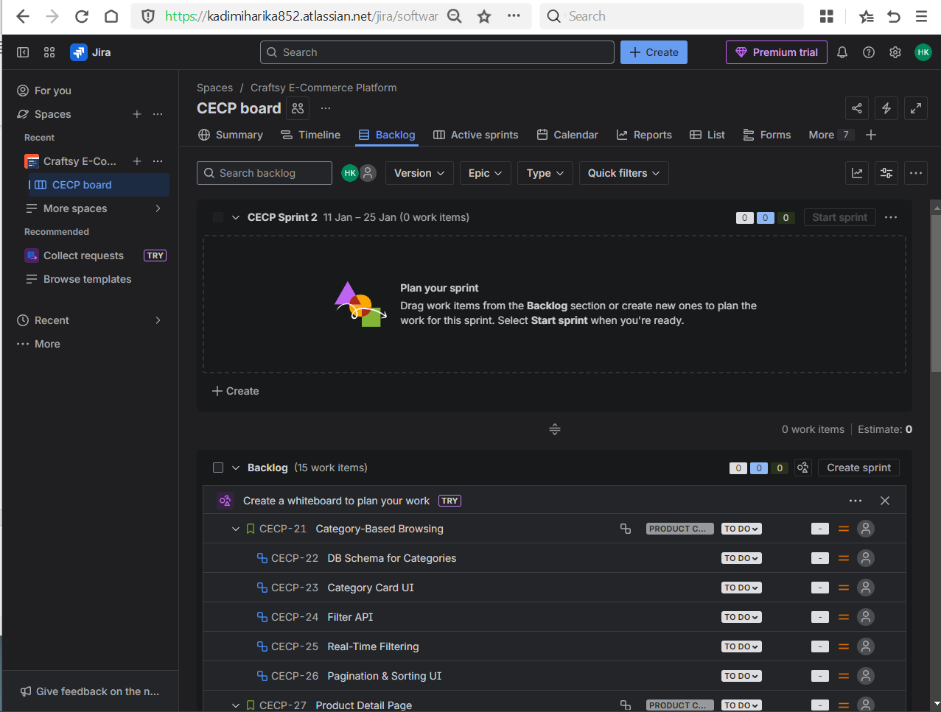
- Added stories to sprint
Added stories and tasks to the sprint based on medium priority.
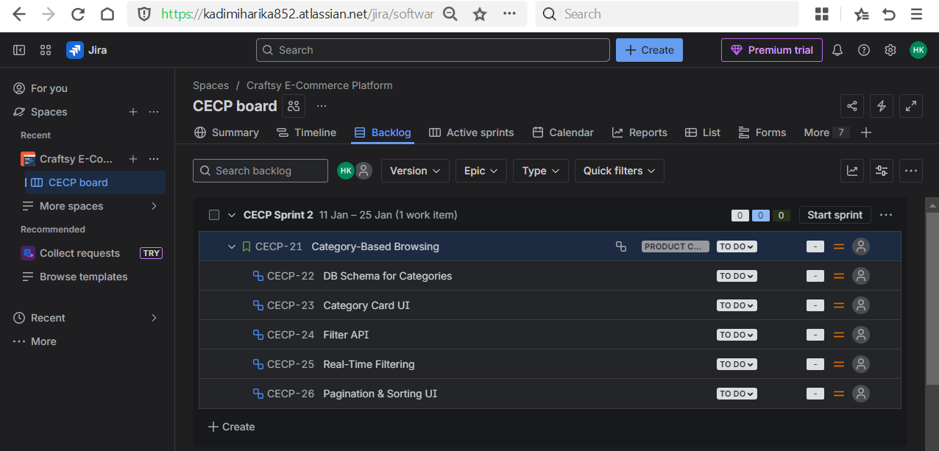

- Started sprint
Started the sprint with a defined duration (1 week).
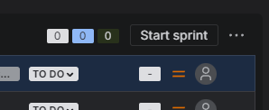
- Moved tasks daily
Moved tasks daily across statuses to simulate daily stand-up updates.
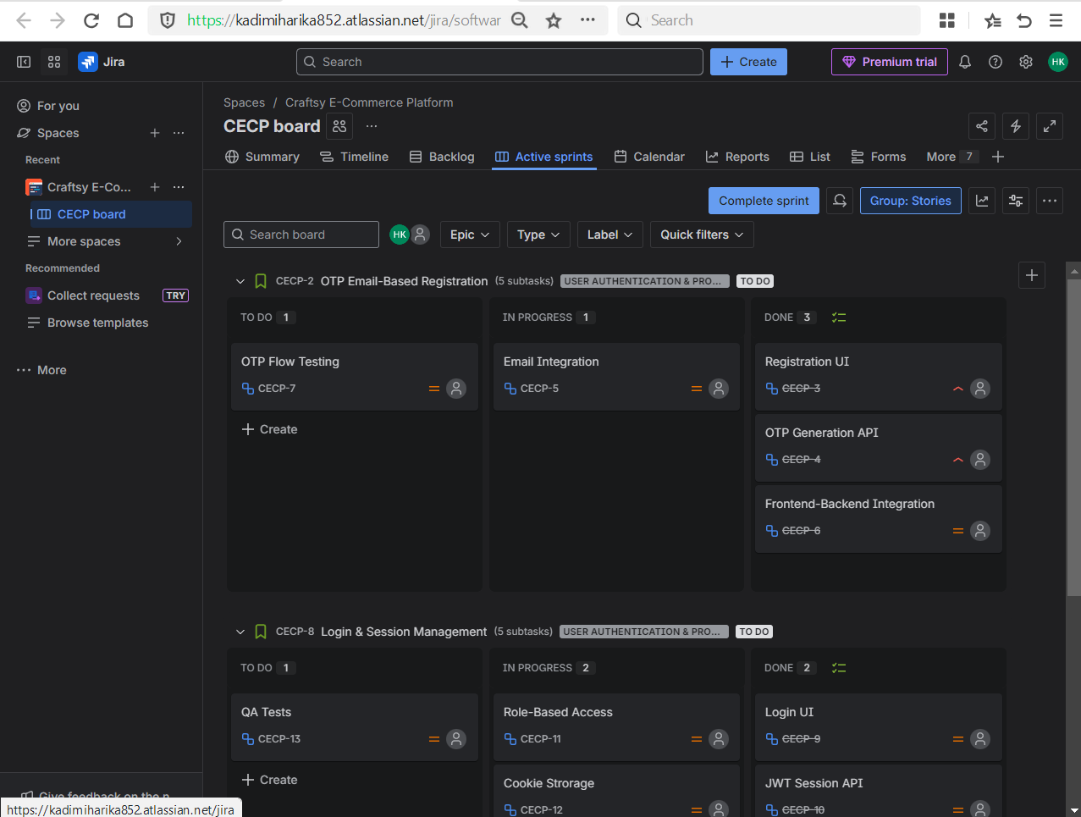
- Completed sprint
Completed the sprint after all work was marked as Done.
